Flag 7: Identify water rights with Non-Consumptive Uses to account for water use returning water diverted back to the system

Function Name: water_use_return

Data Source:

* ewrims_flat_file.csv

<https://intapps.waterboards.ca.gov/downloadFile/faces/flatFilesEwrims.xhtml?fileName=ewrims_flat_file.csv>

* ewrims_flat_file_use_season.csv

<https://intapps.waterboards.ca.gov/downloadFile/faces/flatFilesEwrims.xhtml?fileName=ewrims_flat_file_use_season.csv>

Existing Fields:

* WR_WATER_RIGHT_ID
* USE_CODE
* USE_STORAGE_AMOUNT
* USE_DIRECT_DIV_ANNUAL_AMOUNT

New Fields:

* USE_RETURN

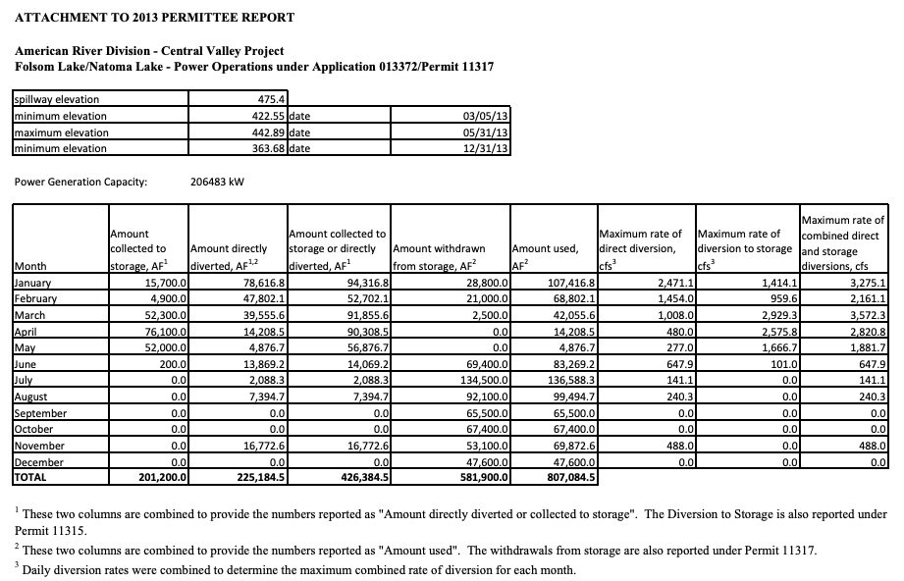

Convert Units (if not AF)

No

Is there a reported “USE_STORAGE_AMOUNT” AND/OR “USE_DIRECT_DIV_ANNUAL_AMOUNT”?

Yes

Yes

No

Yes

“USE_CODE” = “Power”?

“USE_CODE” = “Aquaculture”?

No